1. Overview: 3
2. Setomatic System Network Diagram: 3
3. Main Features 3
4. Technologies Used: 4
5. Third Party Integration 4
6. Setomatic project application classification 4
6.1 SpyderWash Web application 5
6.1.1 Admin Module 5
6.1.1.1 Admin Screenshot 6
6.1.1.1.1 Admin Dashboard 6
6.1.1.1.2 Add new operator 6
6.1.1.1.3 Issue card to operator 7
6.1.1.1.4 Add new location 7
6.1.1.1.5 View Issue loyalty cards 8
6.1.1.1.6 Manage Machine Brand and Model 8
6.1.1.1.7 Pending Registrations 9
6.1.1.1.8 Manage Customer info 9
6.1.1.1.9 Manage Machine type 10
6.1.1.1.10 Manage Hub 10
6.1.1.1.11 Search by Bluetooth ID 11
6.1.1.1.12 Send Bulk mail 11
6.1.1.1.13 Manage Device Info 12
6.1.2 Operator Module 13
6.1.2.1 Operator screenshot 14
6.1.2.1.1 Operator Dashboard 14
6.1.2.1.2 Issue Card to Location 14
6.1.2.1.3 Issue Card to Customer 15
6.1.2.1.4 Reports 15
6.1.2.1.5 Manage Loyalty Card 16
6.1.2.1.6 Manage Attendant 16
6.1.2.1.7 View Spyderwatch 17
6.1.2.1.8 Manage Reload Center 17
6.1.2.1.9 View All Transactions 18
6.1.2.1.10 Manage Receipt Printer 18
6.1.2.1.11 View Clear Total 19
6.1.2.1.12 View Registered Loyalty cards 19
6.1.3 Attendant Module 20
6.1.3.1 Attendant screenshot 21
6.1.3.1.1 Recharge Loyalty Card 21
6.1.3.1.2 Manage Loyalty Card 21
6.1.3.1.3 View Card Transactions 22
6.1.3.1.4 View Registered Loyalty Cards 22
6.1.3.1.5 View All Transactions 23
6.1.3.1.6 Attendant Daily Report 23
6.1.4 Customer Module 24
6.1.4.1 Attendant screenshot 25
6.1.4.1.1 Recharge Loyalty Card 25
6.1.4.1.2 View Transactions 25
6.1.4.1.3 Add new card 26
6.1.5 SpyderWatch: 27
6.2 Windows Services 29

Overview:

The SpyderWash is a web application project and provide a facility to Operators/Merchants to control and monitor their all laundry locations from a single place using one web application and operator can also view different reports. This project will also allow a separate section into the web application to the Super Admin of the entire system that can control and monitor all operators and their Laundromat locations.

Setomatic System Network Diagram:

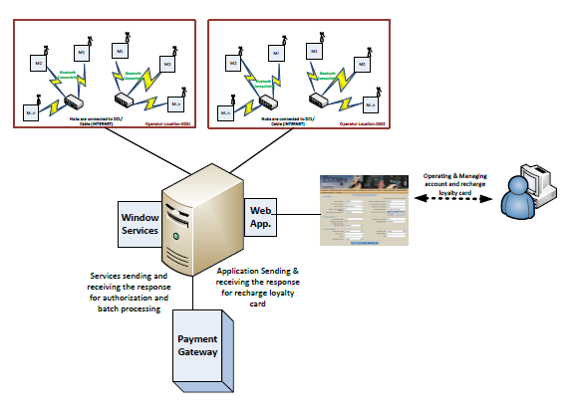

Main Features

- A state-of-the-art application allow Laundromat owners to remotely, control, manage, and operate their laundry locations including each specific machine(Washer/Dryer/Soap Machines).
- Credit card Authorization
- Process Loyalty card Transactions
- Process Cash Transactions
- Encrypt/Decrypt Differ Machine commands(Credit Card, Loyalty Card, Cash) and process on Server
- Developed a functionality that multiple connections can be made on a single port from the different hubs with the same IP.
- Send Notification to Registered Loyalty Card Customer
- SSL Implementation
- Monitor TCP port and Reset if the ports are down
- Post Authorization/Batch the Transaction
- Refund transaction
- Process update
- Monitor Hub Activity If hub is down then send notification email to Laundromat Owner
- Customers Can View Machine Availability- Time Countdown of Machines In Use(SpyderWatch)
- Machine Coin Box Status
- Release Loyalty Card from Customer and assign to new customer
- Ability to manage more than one Loyalty card for customer
- Purchase/Recharge using Cash/Credit Card from Kiosk and Check Loyalty Card Balance
- Generate different transaction report and export to PDF and Excel

Technologies Used:

- Microsoft Visual Studio 2008
- .NET 3.5 Framework
- ASP.Net
- C#
- Web Service
- Windows Service
- LINQ,
- MSMQ,
- TCP/IP Socket Programming
- 3DES Encryption/ Decryption
- MS SQL Server 2008.
- RDLC Report

Third Party Integration

- USAT Payment Gateway
- Merchant Ware Payment Gateway

Setomatic project application classification
Setomatic c Project can be classified in 2 categories:

6.1 SpyderWash Web application
SpyderWash web application has 4 modules:

6.1.1 Admin Module

Admin Module: Admin has the full control over entire web application. Admin can manages all operators and Laundromat locations. Create Loyalty card and issue to operator. Manage Machine Brand and model and also manage hubs. Approve pending registrations Manage Customer information

URL: http://beta.spyderwash.com/somsuperadmin1960/adminlogin.aspx
Login credential:
User name: prabhatv@chetu.com
Password: Setomatic

Admin Menu:
- Admin Dashboard
- Add new operator
- Issue card to operator
- Add new location
- View issue loyalty card
- Manage Machine type
- Manage machine brand and model
- Pending registration
- Manage Hub
- Search by Bluetooth Id
- Send Bulk mail
- Manage Device Info
- Manage Customer info

Admin Screenshot

Admin Dashboard
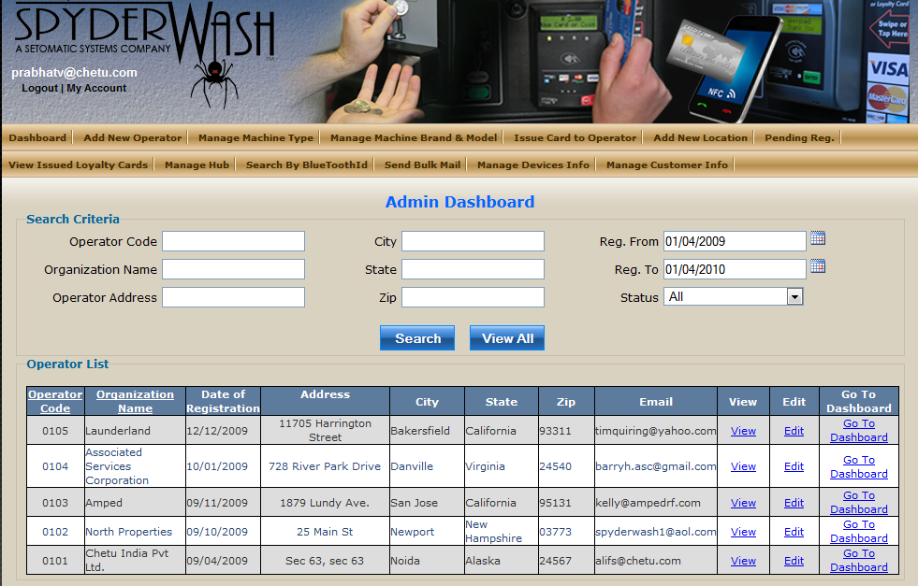

Add new operator

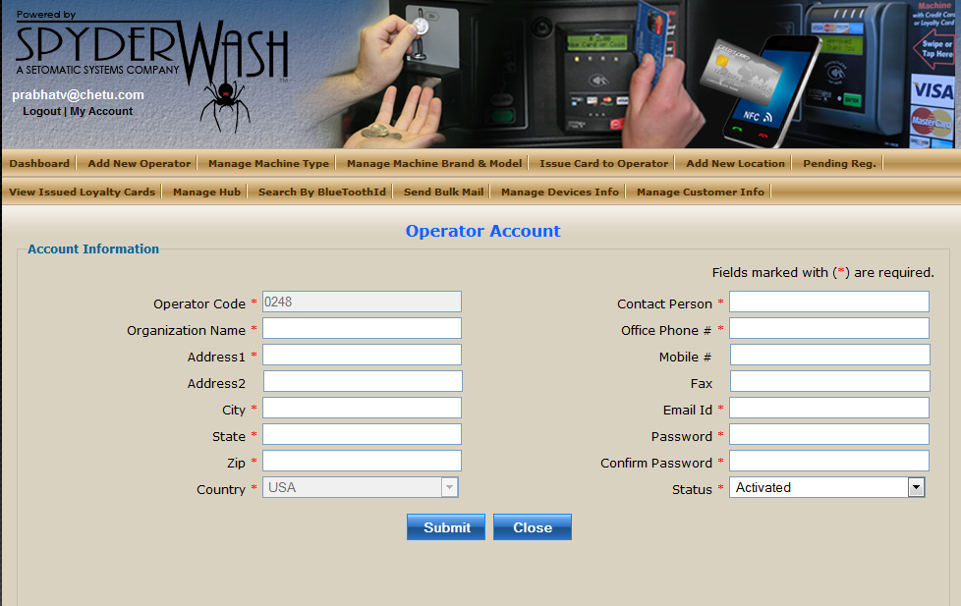

Issue card to operator

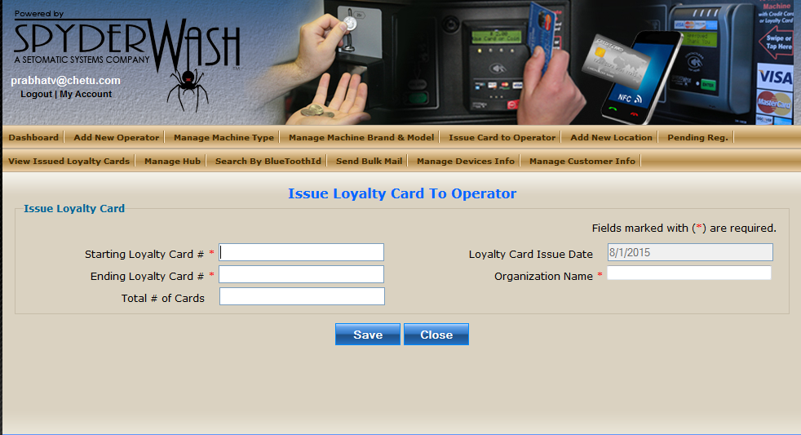

Add new location
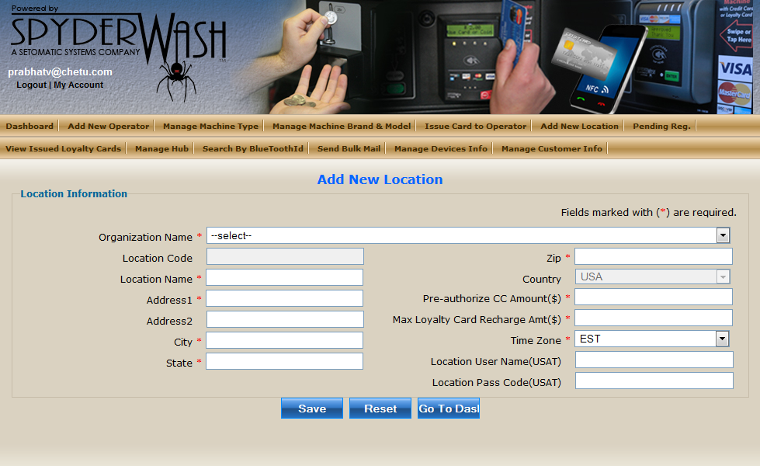

View Issue loyalty cards

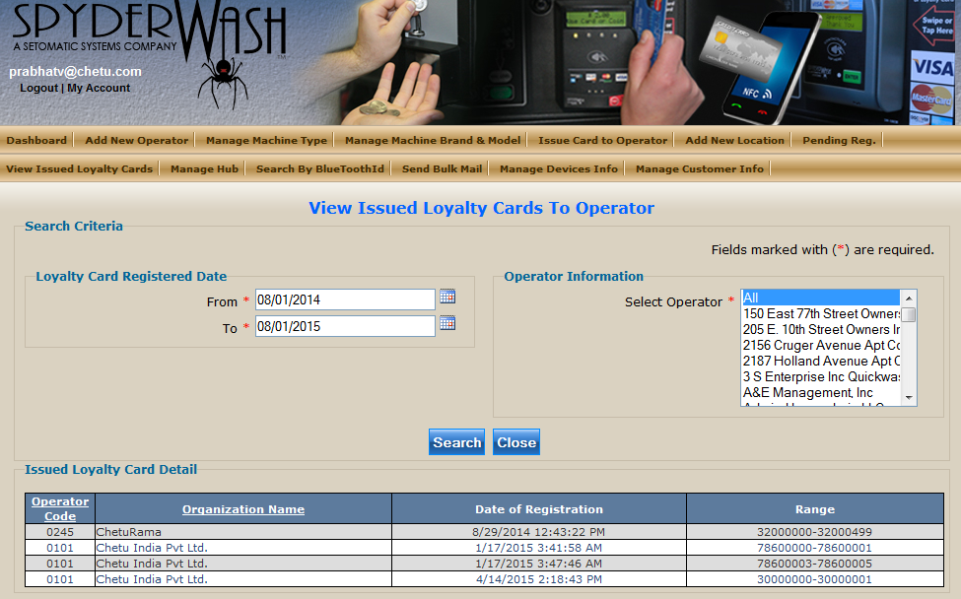

Manage Machine Brand and Model
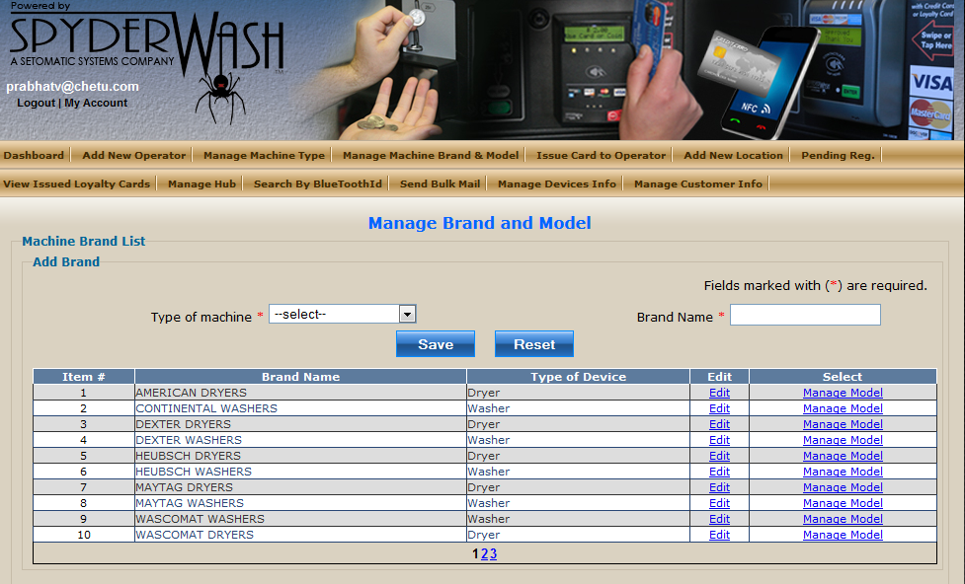

Pending Registrations

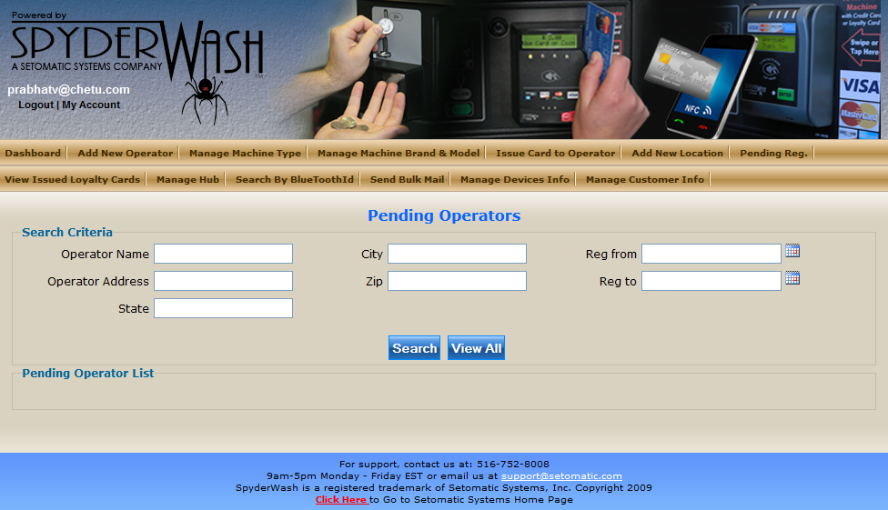

Manage Customer info
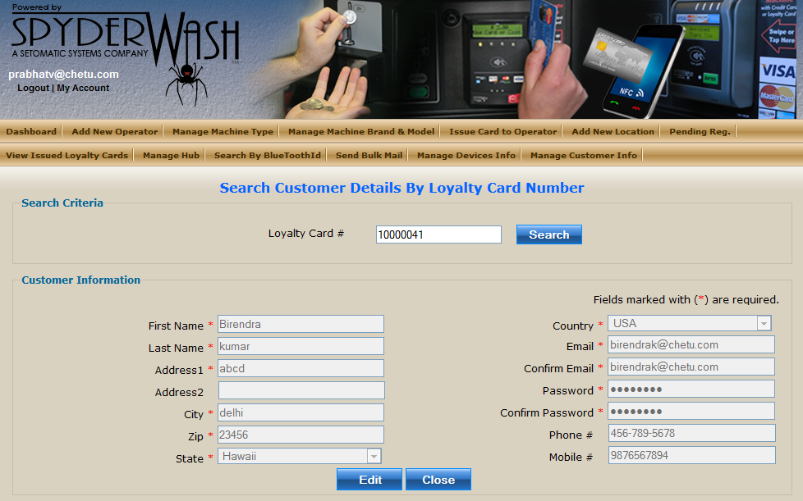

Manage Machine type
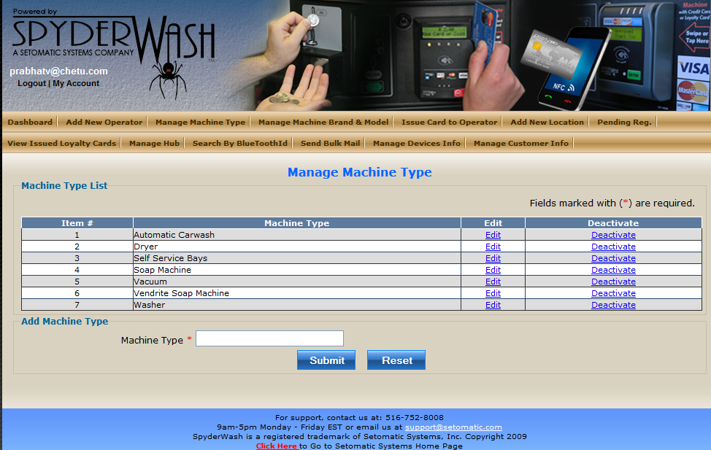

Manage Hub
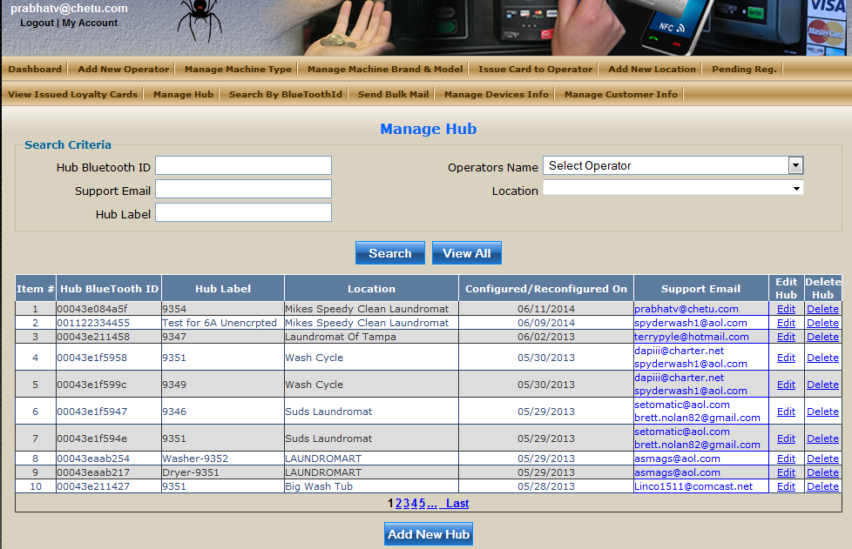

Search by Bluetooth ID
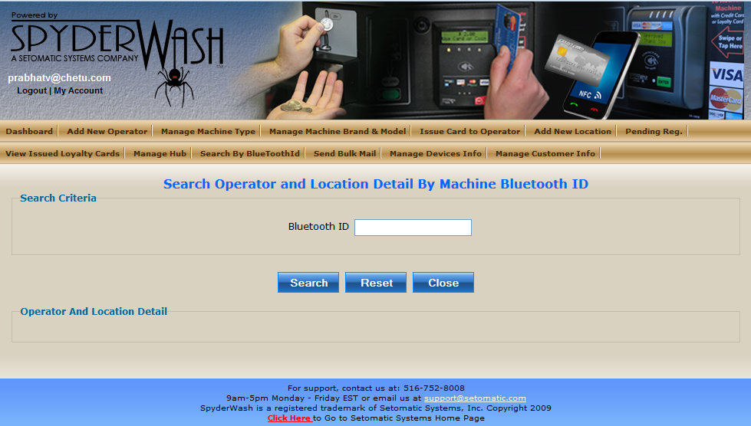

Send Bulk mail
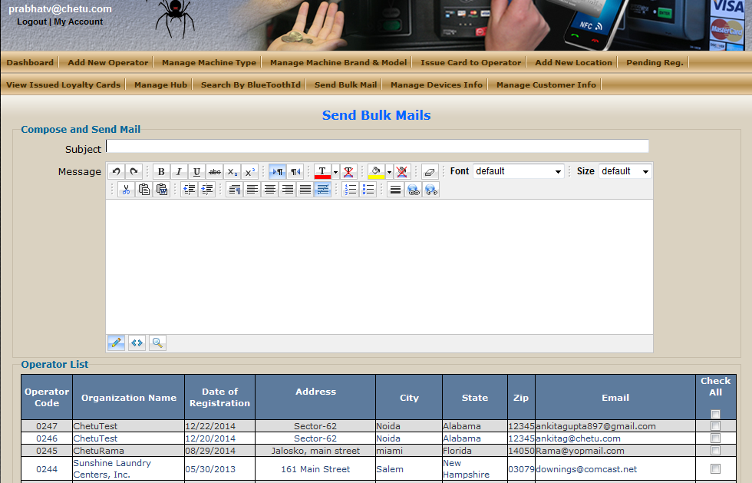

Manage Device Info

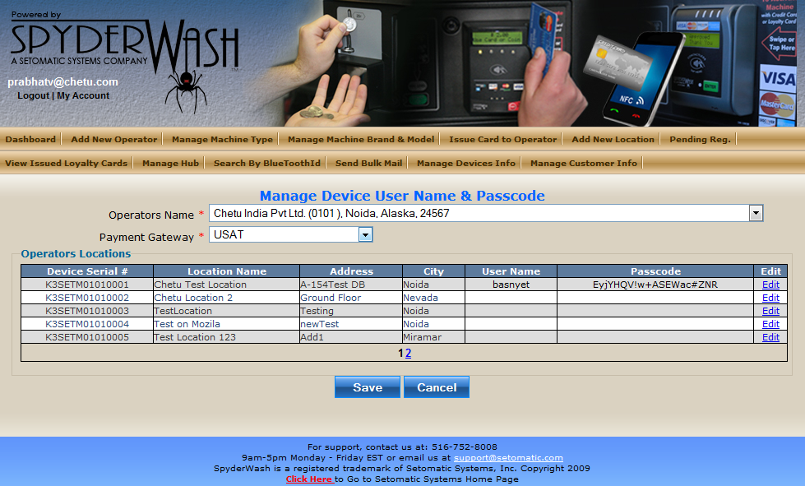

6.1.2 Operator Module

Operator Module: Operators have control and monitor their all laundry locations from a single place. Operators Issue the card to location and then to customer .Create and manage Attendant and give the control to access for selected locations. View SpyderWatch status of running machine.

URL: http://beta.spyderwash.com/Operator/operatorlogin.aspx
Login credential:
User name: alifs@chetu.com
Password: chetu123
Operator Menu:
- Dashboard
- Issue card to location
- Issue card to Customer
- View revenue
- View All transactions
- Generate Report
- Manage Loyalty card
- Manage Attendant
- Manage Receipt Printer
- Clear Total
- View Registered Loyalty card
- View Spyder watch
- Manage Reload Center

Operator screenshot

Operator Dashboard
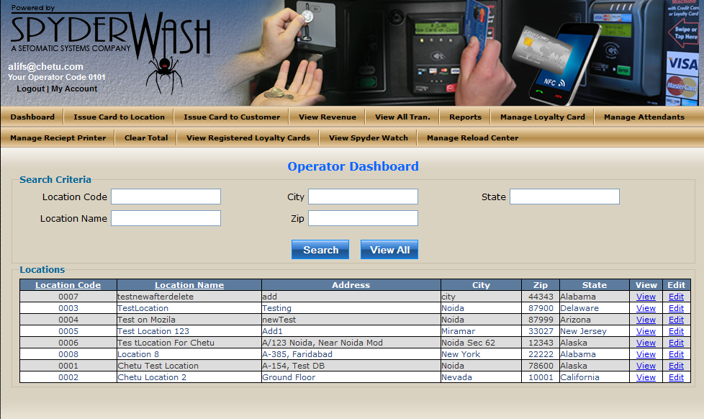

Issue Card to Location
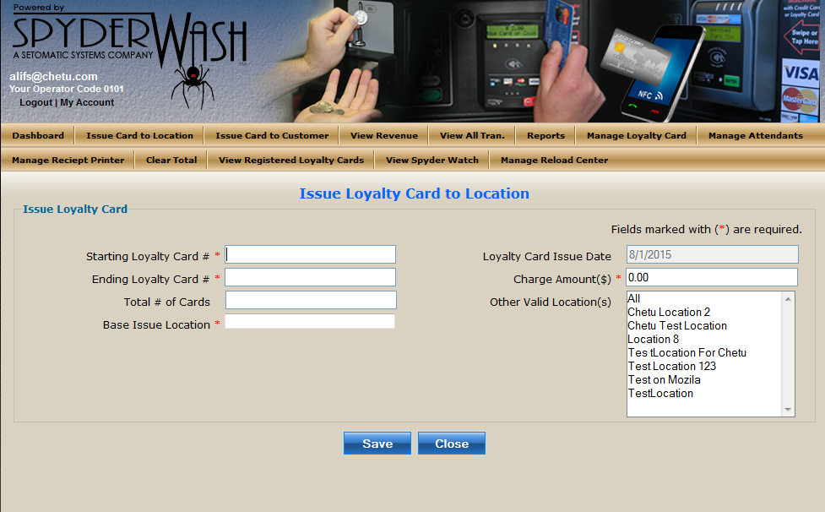

Issue Card to Customer

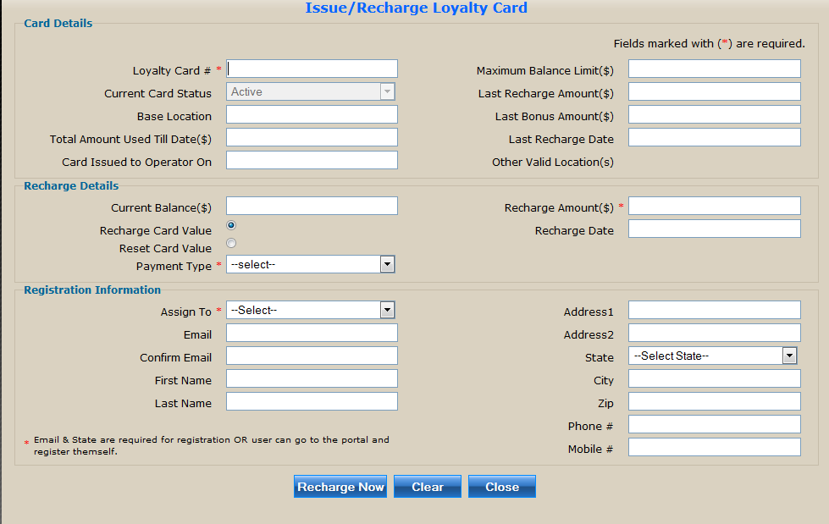

Reports

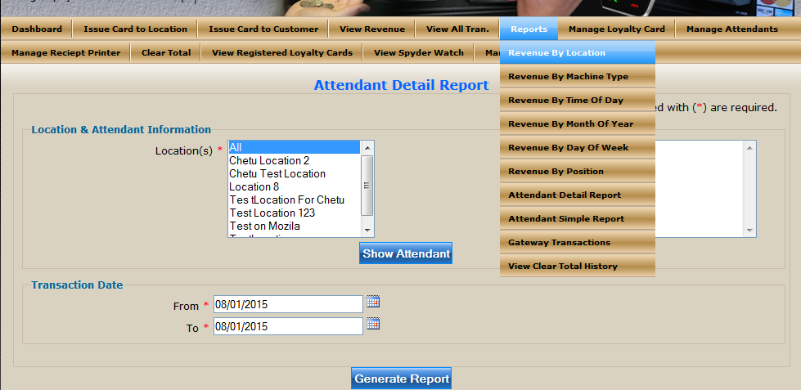

Manage Loyalty Card

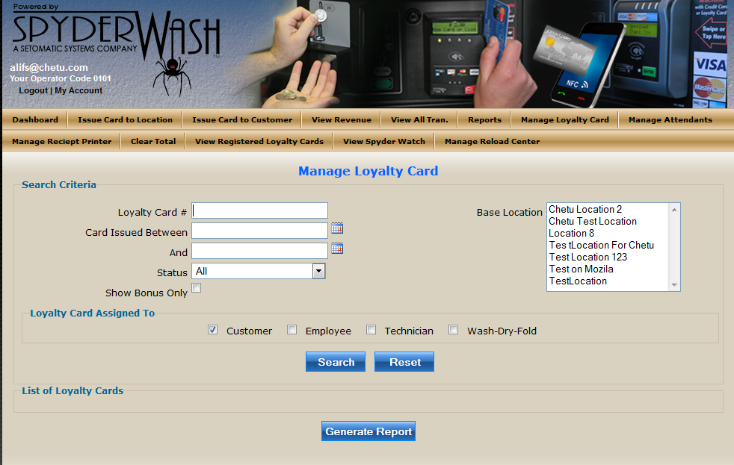

Manage Attendant
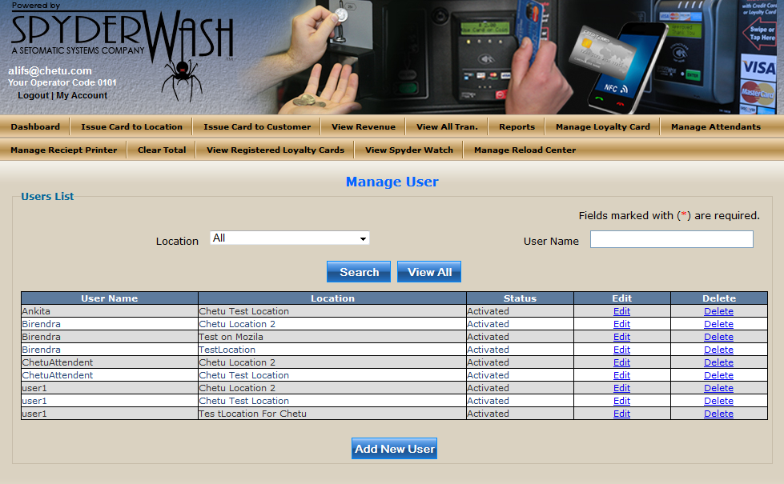

View Spyderwatch

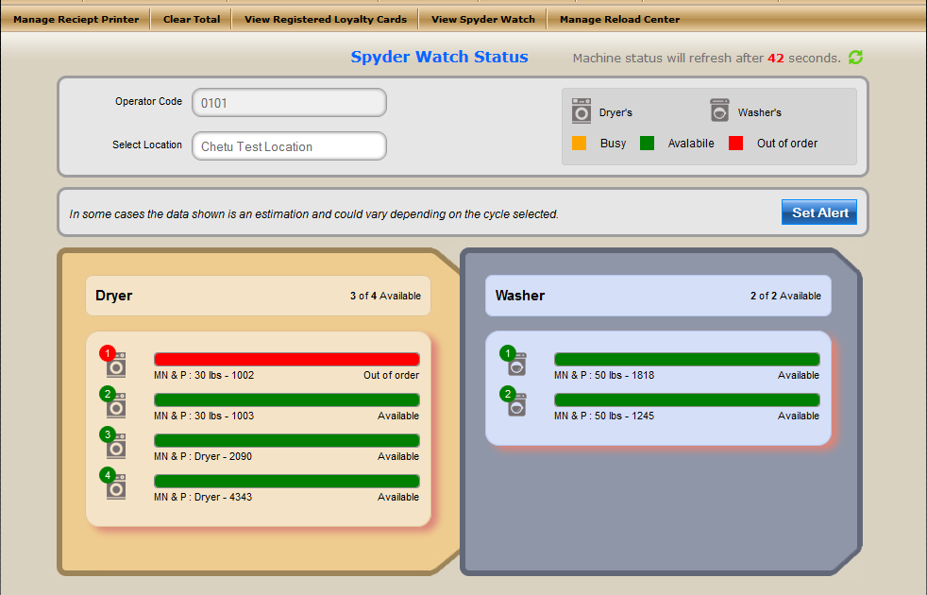

Manage Reload Center

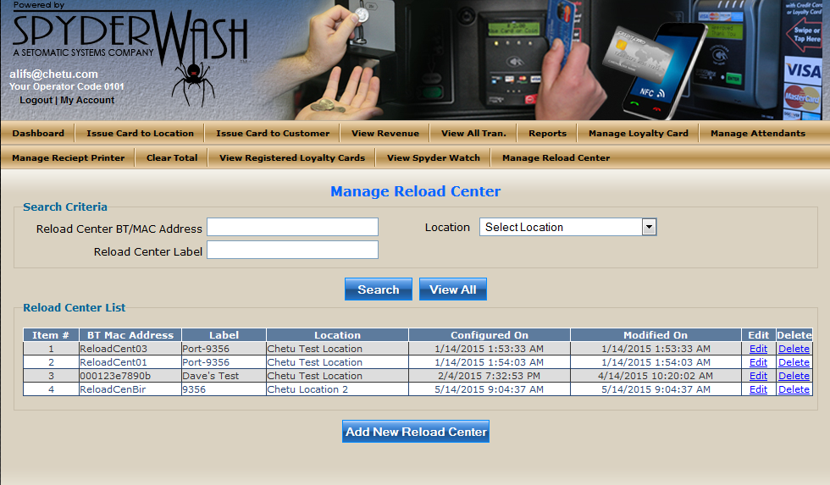

View All Transactions
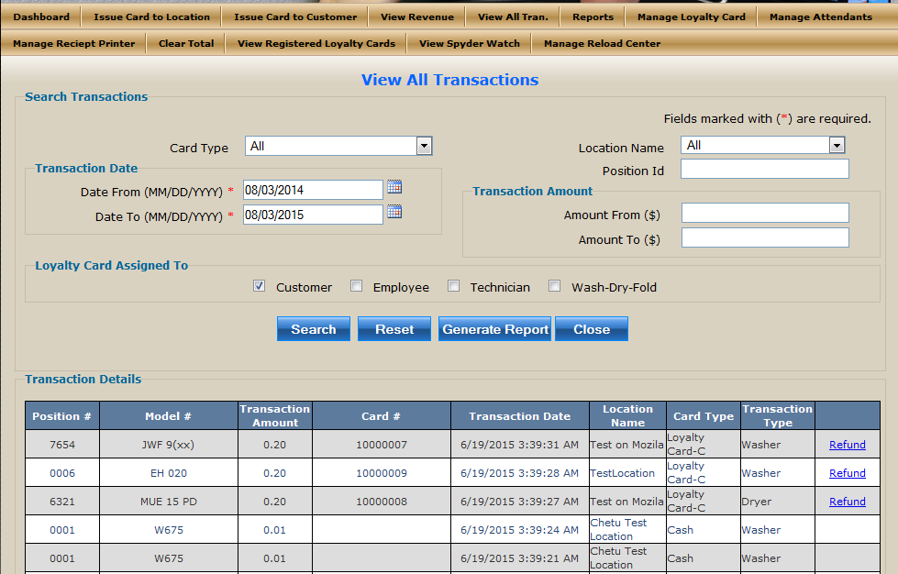

Manage Receipt Printer
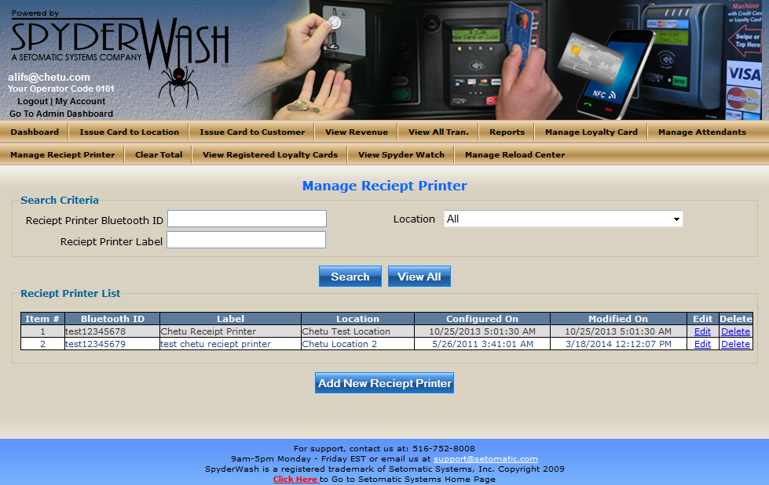

View Clear Total
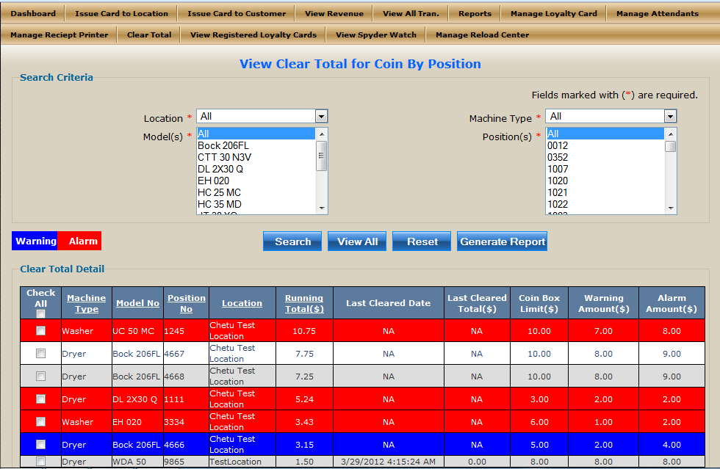

View Registered Loyalty cards
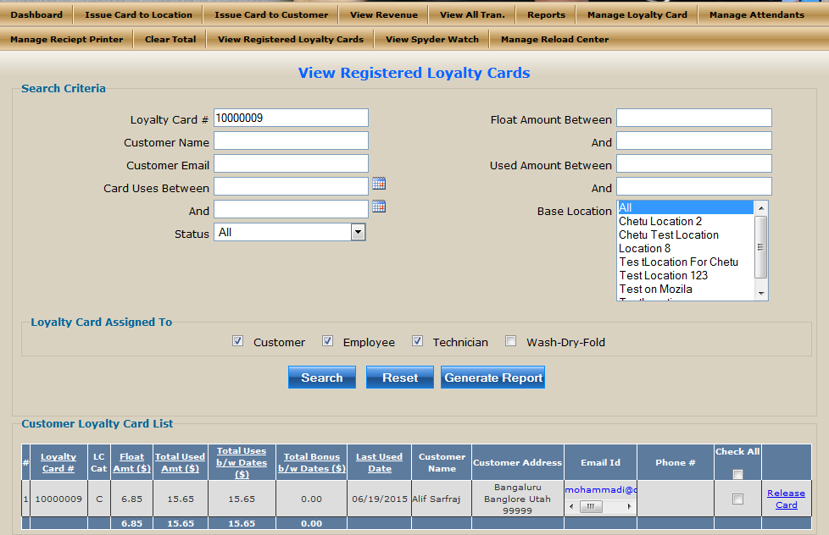

6.1.3 Attendant Module
Attendant Module: Attendant work under the operator and have the control only for those location and pages assigned by operator. Attendant manages and recharge loyalty card. Attendant view and generate transaction report.

URL: http://beta.spyderwash.com/Attendant/AttendantLogin.aspx
Login credential:
Operator code: 0101
User name: Birendra
Password: chetu123

Attendant Menu:
- Recharge Loyalty card
- Manage loyalty card
- View card transaction
- Daily report
- View All transactions
- View registered loyalty card

Attendant screenshot

Recharge Loyalty Card
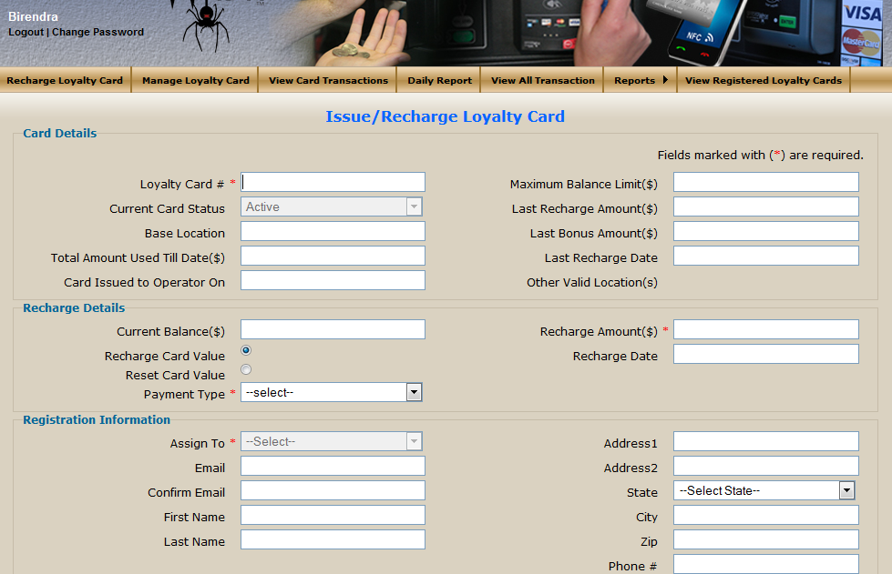

Manage Loyalty Card

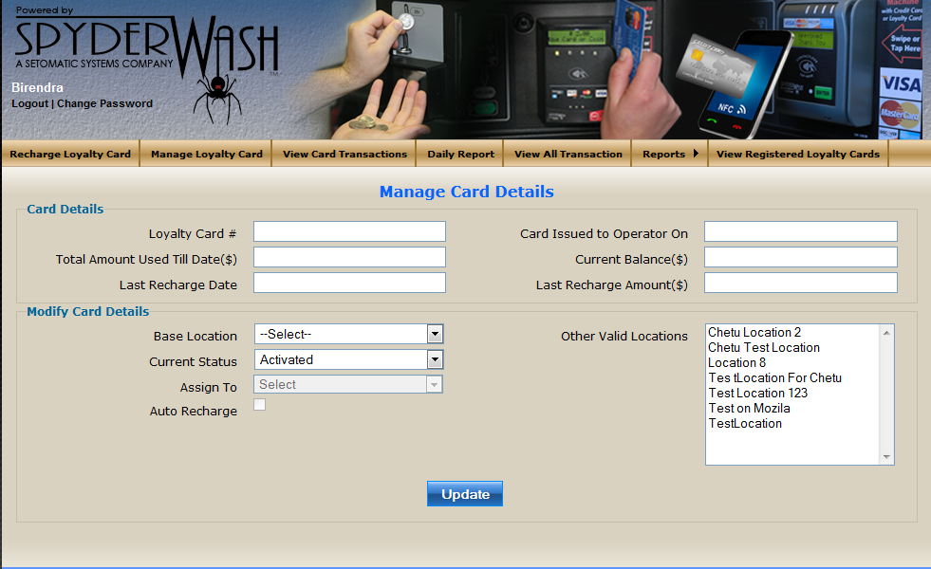

View Card Transactions
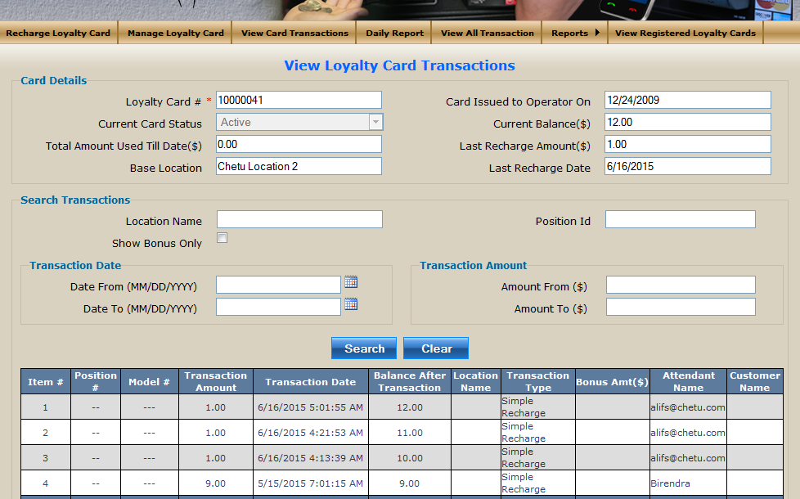

View Registered Loyalty Cards
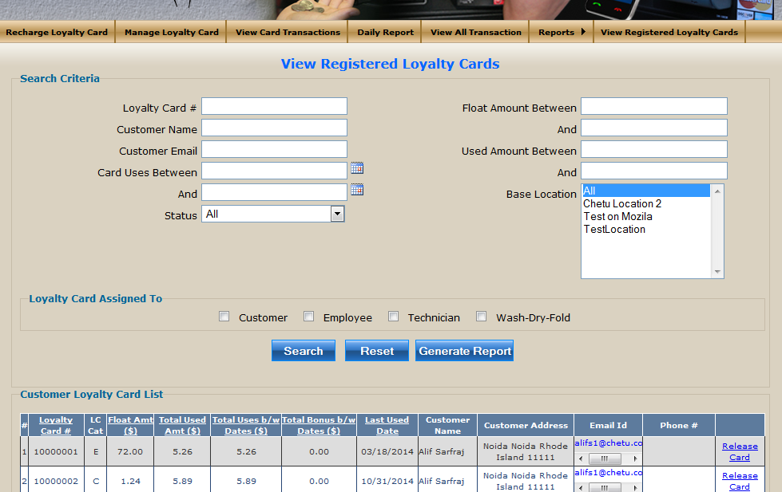

View All Transactions

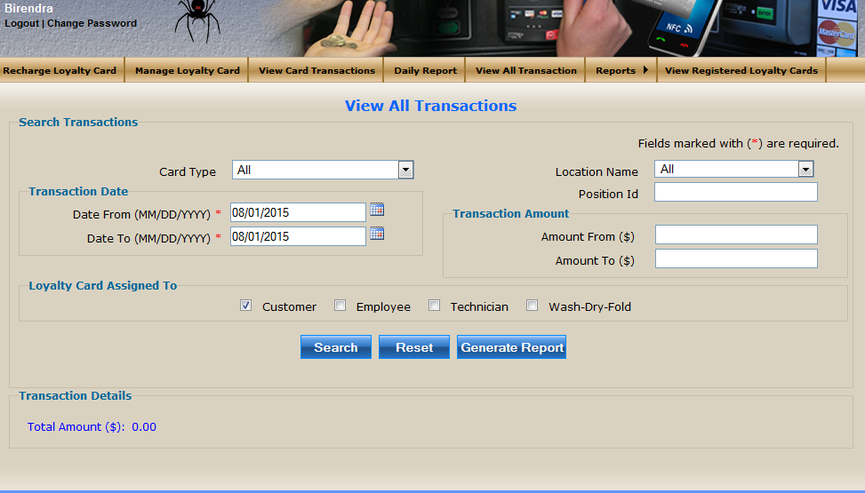

Attendant Daily Report

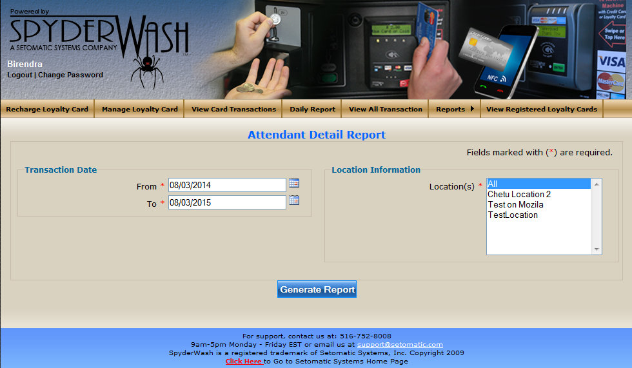

6.1.4 Customer Module

Customer Module: Recharge loyalty card and add new loyalty card issued by operator .they able to view their own card transaction and view Spyder watch machine status and Time Countdown of Machines via Spyder watch login.

URL: http://beta.spyderwash.com/MyCard/CustomerLogin.aspx
Login credential:
User name: alifbkn@gmail.com
Password: chetu123

Customer Menu:

- Recharge Loyalty card
- View Transaction
- Add new card

Attendant screenshot

Recharge Loyalty Card
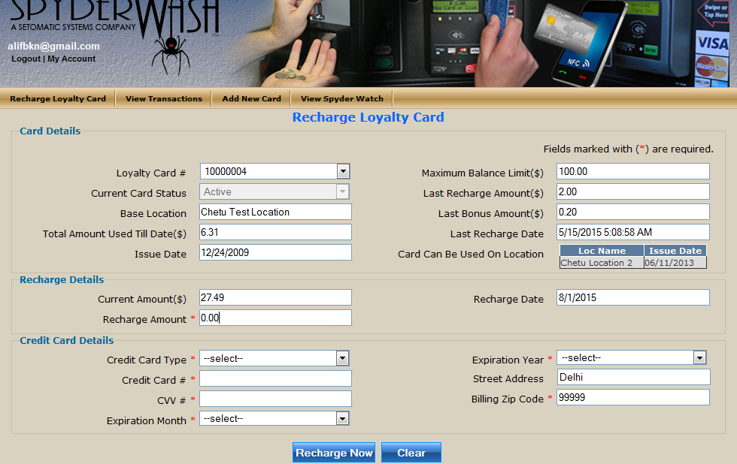

View Transactions
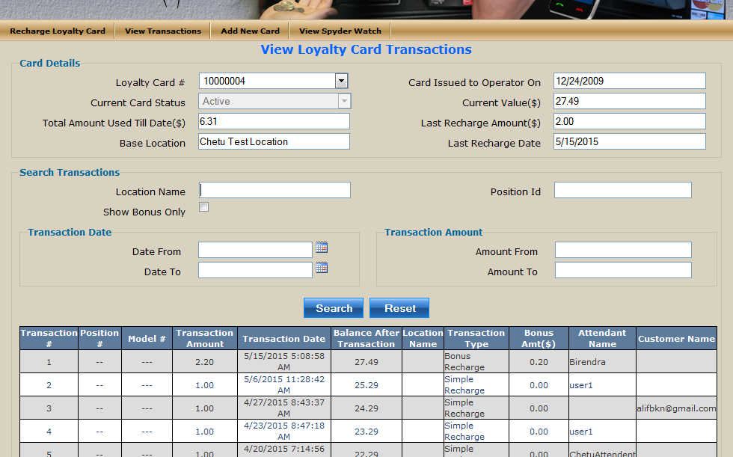

Add new card

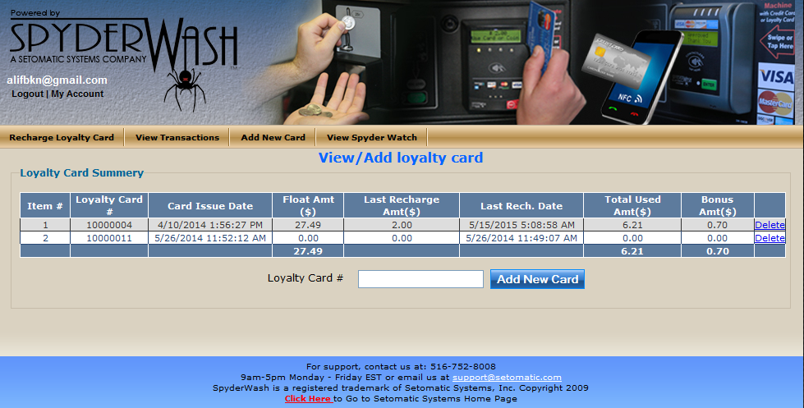

6.1.5 SpyderWatch:
SpyderWatch is an extended feature or functionality that describes how an end customer watches or tracks the live status of laundry machine for a selected or desired location for that operator. This feature also enabled a user who can registered an alert to get the number of machines availability on that location and he can manage and utilize their time in a best way before visiting a laundry for wash and dry. This feature will only work for Washer and Dryer Machines only.

Spyderwtach Login:
URL: http://beta.spyderwash.com/Common/SpyderWatchLogin.aspx
Login credential:
Operator code: 0101
Password: chetu123

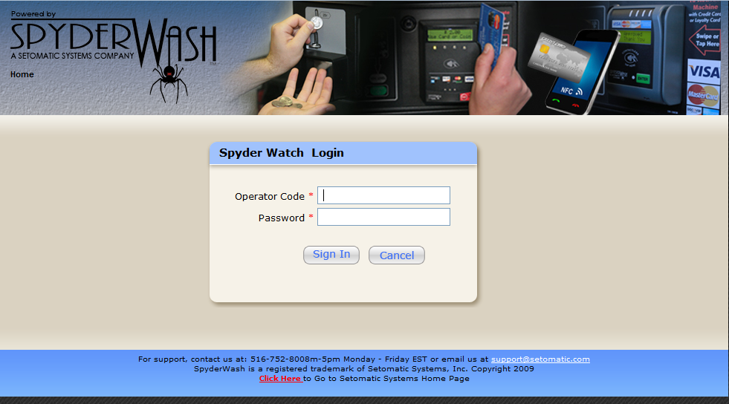
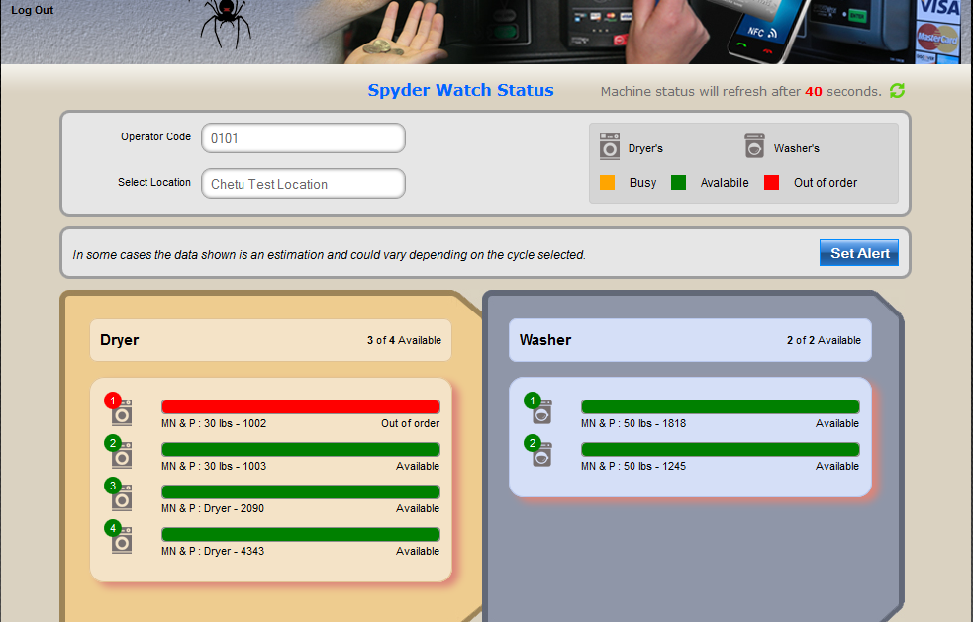

6.2 Windows Services

- Setomatic Service: It is window service which is responsible to process all the live transaction from the different locations of different operators using the socket based TCP connections.

- Setomatic Hub Monitoring Service: This is also a window service which used to send the notification email for the HUB status configured in the system to update the operator about the HUB is down for the last XY minutes.

- Setomatic Port Monitoring Service: Setomatic Service running on 8 different ports so this service used to manage the ports different cases.

- Setomatic Coin Box Email Monitoring: Different machines are configured to accept the coin transaction. This service used to manage the status of Coin Box to send the Alarm and Warning Emails based on the configuration done from the SpyderWash web application.

- Setomatic Post Auth. Service: This service used to process the final settlement for the credit card transactions done with MW payment gateway in different time zones.

- Setomatic Batch Processing: This service used to process final settlement for all the credit card transactions done with USAT payment gateway.

- Setomatic Process Updates: This service used to get and update the updated password if available from the USAT gateway for each devices configure on USAT gateway.

- Setomatic Client: This window application used to test the transaction and commands to verify the changes in Setomatic Service.

- Setomatic Data Reload Center Service: This is newly developed service based on SSL/TLS which will use to process the Kiosk transaction for purchasing and recharging the loyalty card configured into SpyderWash system.

- Spyder watch alert email service: This service configured with Spyder Watch .Once you will submit an alert then “Setomatic Spyder watch alert monitoring service” will monitor your alert and send an alert email to your registered email id when number of required machines are available.

